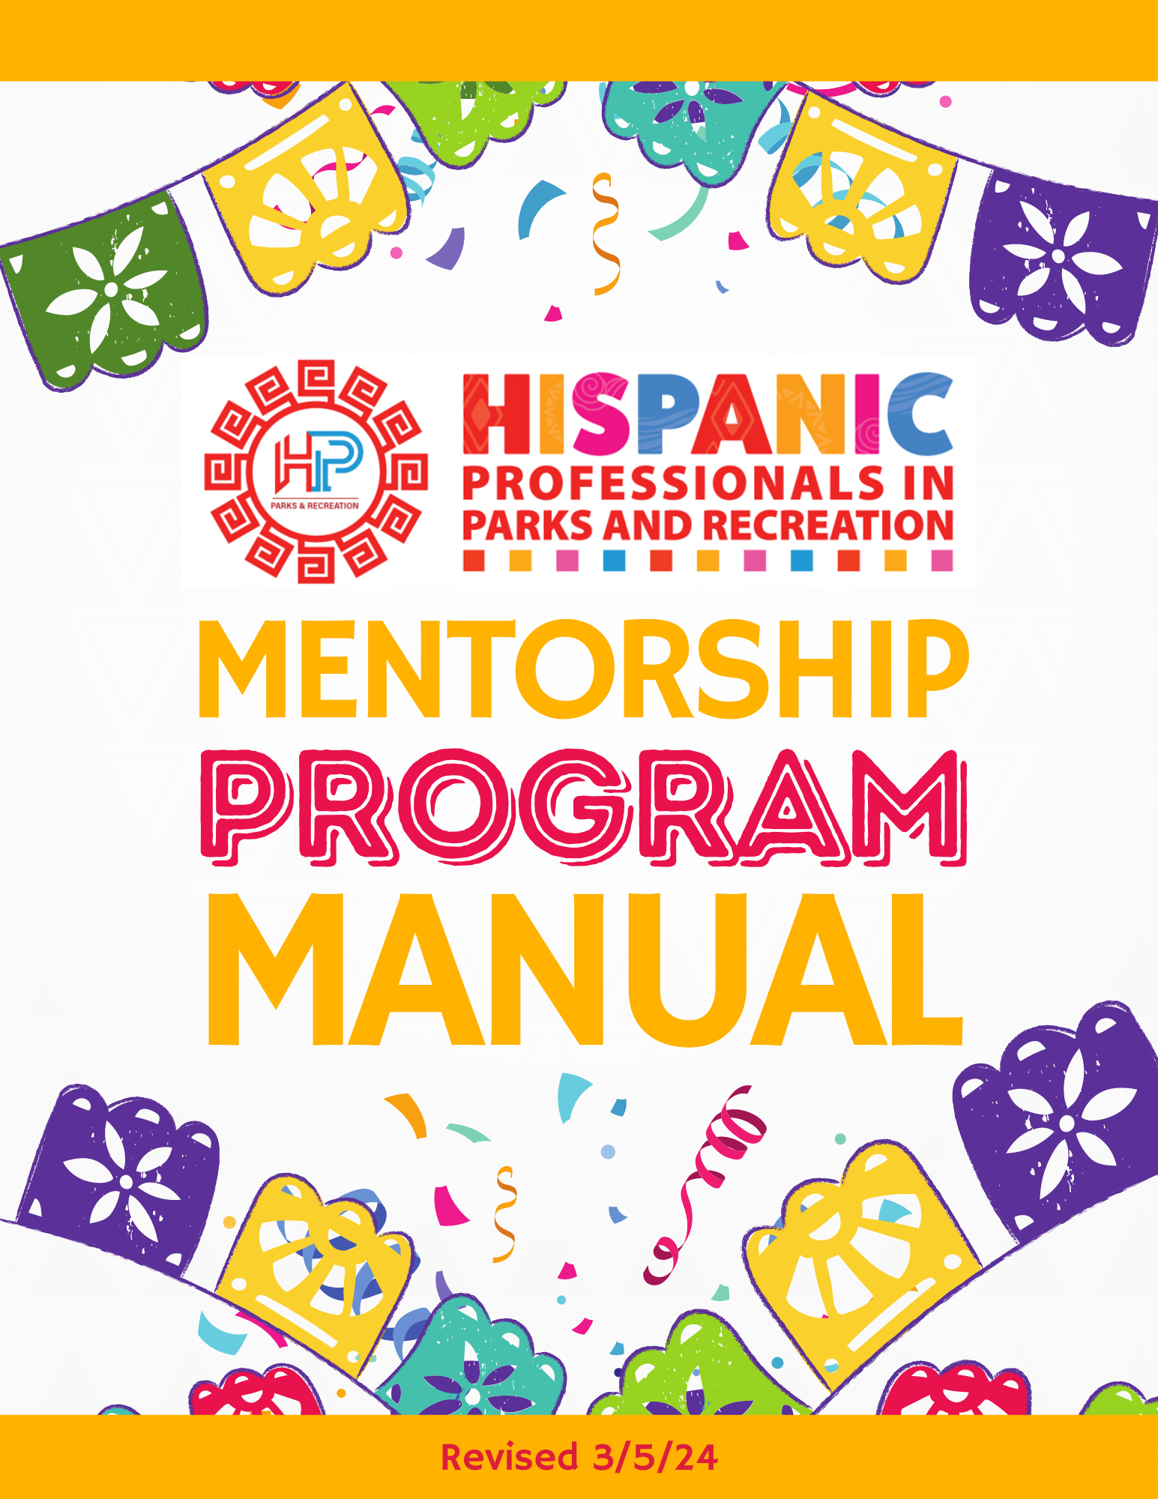

# TABLE OF CONTENTS

Background…………………………………………………………………………………………………………………………………………3

Mentorship Program…………………………………………………………………………………………………………………………..3

Oversight…………………………………………………………………………………………………………………………………4

Eligibility………………………………………………………………………………………………………………………………….4

Application Process…………………………………………………………………………………………………………………4

Matching Mentors with Mentees……………………………………………………………………………………………..4

Switching Mentors/Mentees…………………………………………………………………………………………………….4

Timeline………………………………………………………………………………………………………………………………………………..5

Code of Ethics……………………………………………………………………………………………………………………………………….5

Guidelines…………………………………………………………………………………………………………………………………………….6

**BACKGROUND**

In 2022, a group of dedicated professionals united to establish the Hispanic Professionals in Parks and Recreation (HPPR) with the mission of developing, empowering, connecting, and providing a platform for Hispanics in the parks and recreation profession. The objectives of the group are as follows:

* Actively promote the work and contributions of Hispanics in the parks and recreation

profession.

* Create a supportive environment for Hispanics in parks and recreation to foster professional growth and development.
* Share innovative programs and services that are culturally relevant to Hispanic

communities.

During the formation of HPPR, the concept of a mentoring program was discussed and validated through a survey conducted on Facebook to gauge the needs of the group. Subsequently, the Board of HPPR established a Mentoring Task Force to spearhead the development of a mentoring program. An informal mentoring initiative was rolled out in late 2022, followed by the formal launch of the program in spring 2024.

The Mentoring Task Force is responsible for overseeing the Mentorship Program on an annual basis. The primary aim of the program is to pair professionals to exchange experiences and provide opportunities for professional development.

*\*This manual includes information developed by the Illinois Park & Recreation Association Mentoring Guide which was prepared by Jill Bartholomew, Joanna Tomy, Jeff Wait, Roger Key and Dr. Terry Schwarz and the Academy for Parks and Recreation Administrators Mentoring Program.*

# MENTORSHIP PROGRAM

The Hispanic Professionals in Parks and Recreation (HPPR) program offers professional development opportunities through the establishment of one-on-one mentoring relationships. The objective is for each pairing to facilitate the exchange of knowledge and ideas, with less experienced participants benefiting from the expertise of their mentors while also expanding their professional networks. Mentors are matched with mentees based on factors such as their association (e.g., area of interest, professional experience), shared interests, and geographic location. The duration of the formal mentoring relationship is determined collaboratively by the mentor and mentee.

This manual offers guidance and tips for mentoring, catering to both mentors and mentees. The mentorship program is designed to complement the professional development opportunities available to mentees within their respective workplaces. It is not intended to supplant any existing formal or informal mentoring relationships already established within or outside the mentee's workplace.

HPPR encourages mentors to cultivate multiple informal mentor-mentee partnerships over the course of their careers. This practice not only nurtures the park and recreation profession but also contributes to the cultivation of a robust future workforce. It's worth noting that the majority of mentor-mentee meetings take place virtually or over the phone, and there's no obligation to meet in person at a conference. However, if you choose to do so, it can provide an additional benefit.

**Oversight:**

* The management of the program will be overseen by the HPPR Mentoring Task Force.
* The Chair of the HPPR will appoint a Chair for the program.
* The appointed Chair will collaborate with other members of the HPPR Board and HPPR members to facilitate the program.

**Eligibility**

* Mentees:
  + Must be active members of HPPR.
  + Must demonstrate a willingness to dedicate time to the Mentorship Program.
  + Must be employed (or actively seeking employment) or enrolled as a student in the parks and recreation field.
  + Are encouraged to participate in their local or state parks and recreation association.
  + Must complete and submit the online Mentee Application.
* Mentors:
  + Must be members of HPPR.
  + Must be willing to commit time to the Mentorship Program.
  + Must possess significant experience in the parks and recreation field.
  + Should actively participate in their local or state parks and recreation association.
  + Must complete and submit the online Mentor Application.

**Application Process**

* Enrollment will take place during the open recruitment period for the program.
* Applications will be available on the HPPR Facebook page and website.
* Following the application deadline, the committee will review all applications and proceed to match Mentors and Mentees accordingly.

**Matching Mentors with Mentees**

* Mentors will be matched with Mentees based on factors such as mutual areas of professional interest, availability, geographic location, etc.
* The committee may conduct interviews or follow-up calls with Mentor and Mentee applicants to clarify areas of interest and assess the commitment level of participants.
* Assignments will be made by the committee, and information will be communicated to each Mentor and Mentee.
* An annual deadline will be established for Mentors and Mentees to initiate contact with each other.

**Switching Mentors/Mentees**

* If a Mentor or a Mentee feels uncomfortable with their match, they should direct their comments to the Chair or Co-Chair of the Mentoring Committee: HPPR Mentorship Program Chair, Tony Salinas (tony.salinas@phoenix.gov), or HPPR Mentorship Program Co-Chair, Maria Cepeda (mcepeda@huntersville.org).
* The Chair will first attempt to work with the respective Mentor/Mentee to identify how to make the match work.
* If unsuccessful, the Chair will work to find a new Mentor for the Mentee and vice versa.

**Timeline**

* March 2024
  + Develop a revised Mentorship Program manual for review and approval by HPPR Board.
  + Host a virtual presentation to offer information to prospective mentors and mentees.
  + Solicitation of interest for the 2024 Mentoring Program
* April 2024
  + Application deadline- 4/5/24.
  + Task Force reviews applications and pairs Mentors with Mentees – 4/19/24.
  + Announcement of Mentor/Mentee Pairs made.
  + Task Force conducts follow-up emails/phone calls to Mentor/Mentee Pairs.
* May 2024
  + Mentors/Mentees connect and meet at least once each month – 5/6/24
* October 2024
  + Mentors and Mentees meet at NRPA Conference as able.
  + The formal program concludes coinciding with the NRPA Conference.
* November 2023
  + Collect Mentor/Mentee evaluations.
  + Task Force reviews data and formulates revisions to the Mentor Program.
* January 2025
  + Prepare for the 2025 Mentoring Program.

# CODE OF ETHICS

**As a Mentor within the HPPR Program, I agree to:**

* Treat my mentee with respect and sensitivity.
* Maintain a professional relationship rather than a social one.
* Keep any disclosures confidential unless my mentee grants permission otherwise.
* Focus on providing knowledge and insight into the workplace.
* Avoid assuming the role of counselor, regardless of issues raised by my mentee.
* Support your mentee in achieving their goals.
* Assist in growing my mentee’s professional networks.

**As a Mentee within the HPPR Program, I agree to:**

* Not ask or expect my mentor to provide me with a job.
* Actively seek to be developed throughout the mentoring relationship.
* Maintain professional conduct without expecting friendship.
* Take the mentoring relationship seriously by striving to meet all commitments.
* Commit to achieving my goals.
* Communicate with your mentor at agreed-upon times.
* Be open to learning, actively listen, and apply strategies and approaches recommended by my mentor.

*\*adapted from the Alberta Mentorship Program*

# GUIDELINES

Mentors and Mentees should recognize the importance of their mentoring relationship, even if it is informal. Despite its informality, the exchange of ideas, feelings, and emotions requires active listening and empathy. Both Mentors and Mentees should approach each session positively, openly, and honestly, while also being dependable and prepared, and showing mutual respect.

**Mentor Guidelines**

* Be accessible and available to your mentee.
* Develop a professional understanding of your mentee.
* Offer guidance on professional development.
* Prioritize your role as a mentor.
* Share your experiences and personal stories, as they offer valuable and memorable insights.
* Share both your failures and successes, as they provide powerful learning experiences.
* Pose thought-provoking questions to encourage reflection and evaluation.
  + Good questions require confrontation, evaluation, and reflection.
  + What does the mentee think about their career?
  + How would they like to be helped?
  + What expectations do they have about you?
* Support your mentee when needed.
* Regularly assess the mentoring relationship to ensure it meets expectations and provide positive and constructive feedback.
* Don't hesitate to admit, "I don't have the answer right now, but I'll find out and get back to you."

**Mentee Guidelines**

* Be open to suggestions but trust your own judgment.
* Take ownership of your career management.
* Act confidently, recognizing the value you bring to the relationship.
* Don't hesitate to ask questions; your mentor is there to provide guidance and knowledge.
* Respect the confidentiality of mentoring conversations, being open and sincere about your challenges. Understand that your mentor may share confidential information, and refrain from making it public.