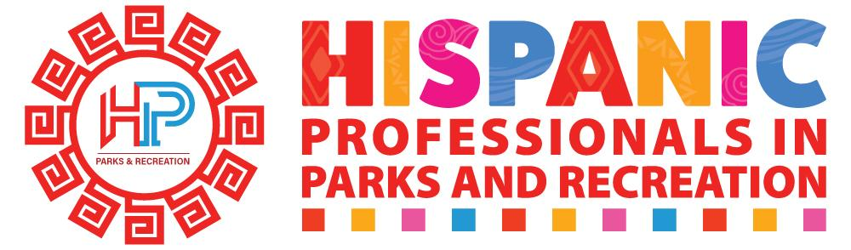
Informal Mentee Application

Thank you for your interest in the Hispanic Professionals in Parks and Recreation (HPPR) Mentorship Program. This opportunity is available to HPPR members seeking personal and/or career growth and development.

The purpose of this program is to facilitate professional connections where members can reach out to mentors on an as-needed basis, rather than establishing formal ongoing mentoring relationships.

Name:_____________________________________________________________
Position: ___________________________________________________________
Agency: ____________________________________________________________
Email: _____________________________________________________________

Positions held:
- _____________________________________________________________

- _____________________________________________________________
- _____________________________________________________________
- _____________________________________________________________

What methods are best for you to be INITALLY contacted?
- Email
- Text
- Linkedin
- Facebook
- Phone
Do you feel comfortable communicating (speaking/writing) in:
- Spanish Only
- English Only
- Able to communicate in both English and Spanish

Years in the field: (check only one)
- 0-5 years
- 6-10 years
- 11-15 years
- 15-20 years
- 21+ years

What types of agencies have your worked for in your career? (check all that apply)
- Municipal
- Special Purpose District
- State
- Federal
- Non Profit
- For Profit

What experience do you have in the parks and recreation field? (check all that apply)
- Programming (youth/adult)
- Facility Management
- Special Events
- Park Operations
- Aquatics
- Senior Programming
- Park Planning
- Marketing/Communication

Would you prefer a mentor at a peer level or other position? (please select all that apply)

- Lower Level
- Peer
- Higher Level
- No Preference

Please list a goal you would like to reach as a result of the HPPR Mentorship Program. (please be specific)

________________________________________________________________________________________________________________________________________________________________________________________________________________________________________________________________________________________________________________________________________________________________________________________________________________________________________________________________________________________________________________________________________________________

